
SOP Title: | eCommerce C-Stock HHP Disposition
Document Storage Location: | STACS/Management/SOPs – Logistics and Warehousing | Document #: | SEASOP437v100
SOP Originator: | Valentina Popadic | Last Edited by: | Erwin Dela Pena
Effective Date: | 07/13/2021 | Last Edited Date: | 06/08/2022
Other: | NERP Access Required.

- Purpose
  - To document processes, procedures, and standards for the eCommerce (eComm) inventory disposition for C-Stock Handheld Phone (HHP) material.
- Scope
  - Policies and responsibilities governing Samsung eComm HHP C-Stock shipments to Samsung Triage partner.
- Responsibilities
  - The SEA eComm Operations team shall create the PUMI and submit for approval.
  - The SEA eComm Operations team shall designate which Samsung Triage partner will be forwarded the HHPs.
  - The 3PL eComm team (3PL) shall create inventory reports using their Warehouse Management System (WMS) to provide to SEA eComm teams.
  - The SEA Logistics, Planning & Shared Services (LPS) eComm team shall manage communication with Triage partner.
  - The LPS eComm team shall utilize NERP to keep records of C-stock.
- Instructions
  - LPS team determines how many units of C-Stock HHP SKUs should be sent to the triage partner.
    - Request ‘C-Stock On Hand Report’ from 3PL Inventory team.
    - In GMP
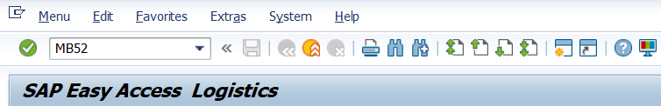
      - Run MB52 T-code.

      - Enter Plant.
      - Enter Storage Location.
      - Select Execute icon (F8).

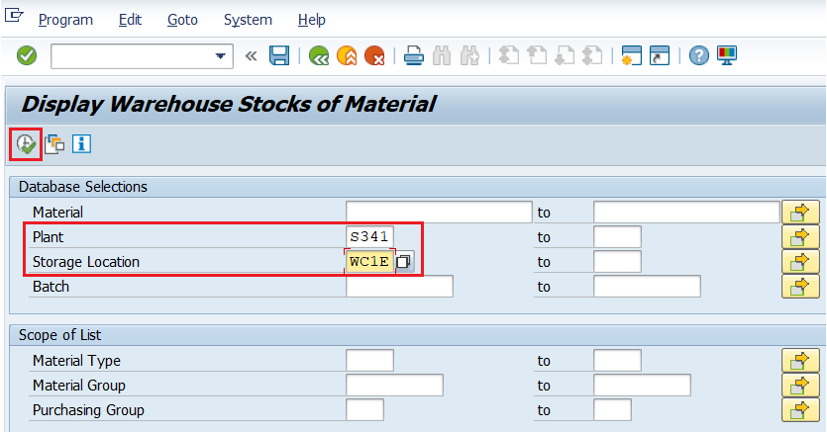
      - Download GMP file.
    - Create B-Stock Report: Compare GMP file with ‘B Stock On Hand’ reported numbers from 3PL WMS.
      - Isolate ‘GMP Blocked Stock’ column in report.
      - The only stock that can be approved for scrapping must have enough GMP Blocked Inventory.
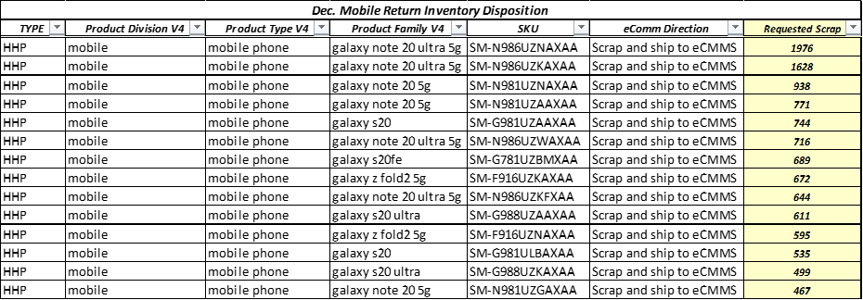
      - Final numbers from GMP file are shared with SEA eComm Operations contact for PUMI submission.
PivotTable of available B-Stock report in 3PL WMS

  - LPS team sends the C-Stock report to
    - SEA eComm Operations team
      - Charles Kim: charles1.k@partner.sea.samsung.com
    - LPS Returns Manager
      - Erwin Dela Pena: e.delapena@sea.samsung.com
  - PUMI Creation and Approval
    - SEA eComm Operations team creates the PUMI and submits for approval.
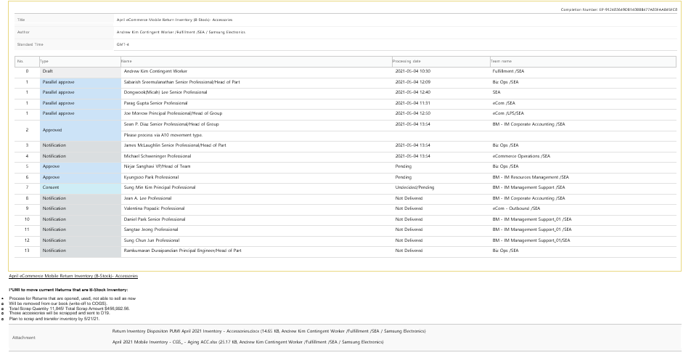
Example of B-Stock PUMI
    - SEA eComm Operations team designates in the PUMI which Triage partner will triage the HHPs.
    - LPS team is notified of Approved PUMI via email.
    - The LPS team to provide the list of items to be picked to the 3PL and determines the due date for pickup.
    - 3PL begins the picking process.
  - Picking Process
    - LPS team
      - Forwards the list of items to 3PL.
      - Requests 3PL to start pulling the approved quantity.
      - The pull list should contain
        - Item
        - Item UPC
        - SKU Type
        - Item Description
        - Authorized picked quantity
        - Total Quantity
    - 3PL Inventory Supervisor
      - Creates a separate file with locations for each item.
      - Distributes the file to the associates pulling the scrap items.
      - Notifies LPS on pull status and specifies if there delays.
    - 3PL Inventory Team associate picks the product from their locations.
    - 3PL systematically in WMS
      - Moves the LPs (license plates) from their locations to designated scrap bin locations (SCRAPHHP).
      - Assigns a master LP to each carton of HHPs.
    - Then, 3PL associates
      - Scan the UPC and IMEI information on product boxes into a spreadsheet.
      - Verify that the quantity of the scanned items matches the ‘Approved Quantity’ on the list.
    - The next morning, as a second verification the 3PL Inventory Control (IC) team performs cycle counts on the bin which containted the material.
      - Communicate discovered variances to 3PL IC Manager for further research.
    - 3PL provides list of the pulled and verified IMEIs to the LPS team.
      - Also provide a list of IMEIs for each carton to validate at the carton level.
    - LPS team sends IMCE an Advance Shipping Notice (ASN) from 3PL for verification of receipt.
      - The ASN must include
        - IMEIs
        - SKUs
    - LPS Inventory team member reviews the number of IMEIs and performs verification and alignment with 3PL IC Manager.
    - LPS and 3PL teams adjust their systems.
      - 3PL performs adjustments in 3PL WMS.
        - Use ‘SC’ (scrap) transaction code.
        - Make a comment including time stamp/PUMI sent from LPS team.
          - Allows for future research.
        - Send email to LPS team when adjustments have been completed.
          - LPS eComm email distribution list.
      - LPS performs adjustments in GMP.
        - T-Code MB1C.
        - Movement type A10.
        - Plant S341.
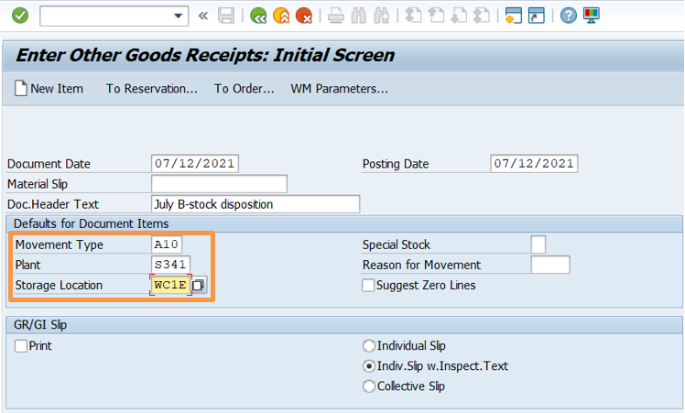
        - Storage location WC1E.

        - Save.
        - Copy and save Material Document # from GMP for records and to share with Accounting.
          - Provides proof of transaction/adjustment for auditing.

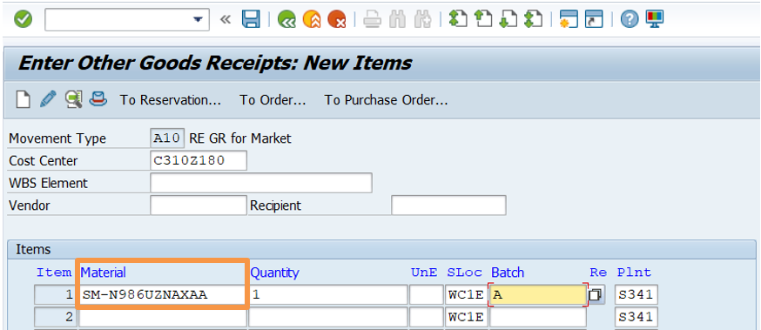
  - Shipment Preparation
    - Once the system adjustments are complete, the LPS team ensures all boxes are correctly labeled and palletized for transit to IMCE.
      - Everything is shipped via LTL (less than truckload) shipment to IMCE.
  - LPS team sends an email to SEA Transportation requesting pickup for delivery to IMCE.
    - Send request to email: SEA-Transportation@sea.samsung.com
    - Include delivery address:
ECMMS - Steve Yu
8303 Fallbrook Drive, Dock #42
Houston, Texas 77064
Office (281) 477-4007
Mobile (909) 718-9346

- Related Documents

